IOT Experiment - 2

Teena tejaswi

122010315029

**Experiment No 2**

**Aim:** Read data from a sensor. Experiment with both analog and digital sensors.

**Objectives**: Student should get the knowledge of Temperature Sensor and IR sensor

**Outcomes:** Student will be developed programs using Arduino IDE and Arduino Board for Temperature Sensor and IR sensor

**Connecting to a Temperature Sensor**

These sensors have little chips in them and while they're not that delicate, they do need to be handled properly. Be careful of static electricity when handling them and make sure the power supply is connected up correctly and is between 2.7 and 5.5V DC - so don't try to use a 9V battery!

They come in a "TO-92" package which means the chip is housed in a plastic hemi-cylinder with three legs. The legs can be bent easily to allow the sensor to be

plugged into a breadboard. You can also solder to the pins to connect long wires

**Reading the Analog Temperature Data**

The sensor has 3 pins 2 pins are used to power the sensor and third one is the analog output. To read the temperature value from the sensor, connect the output pin directly into an Analog (ADC) input of Arduino board.

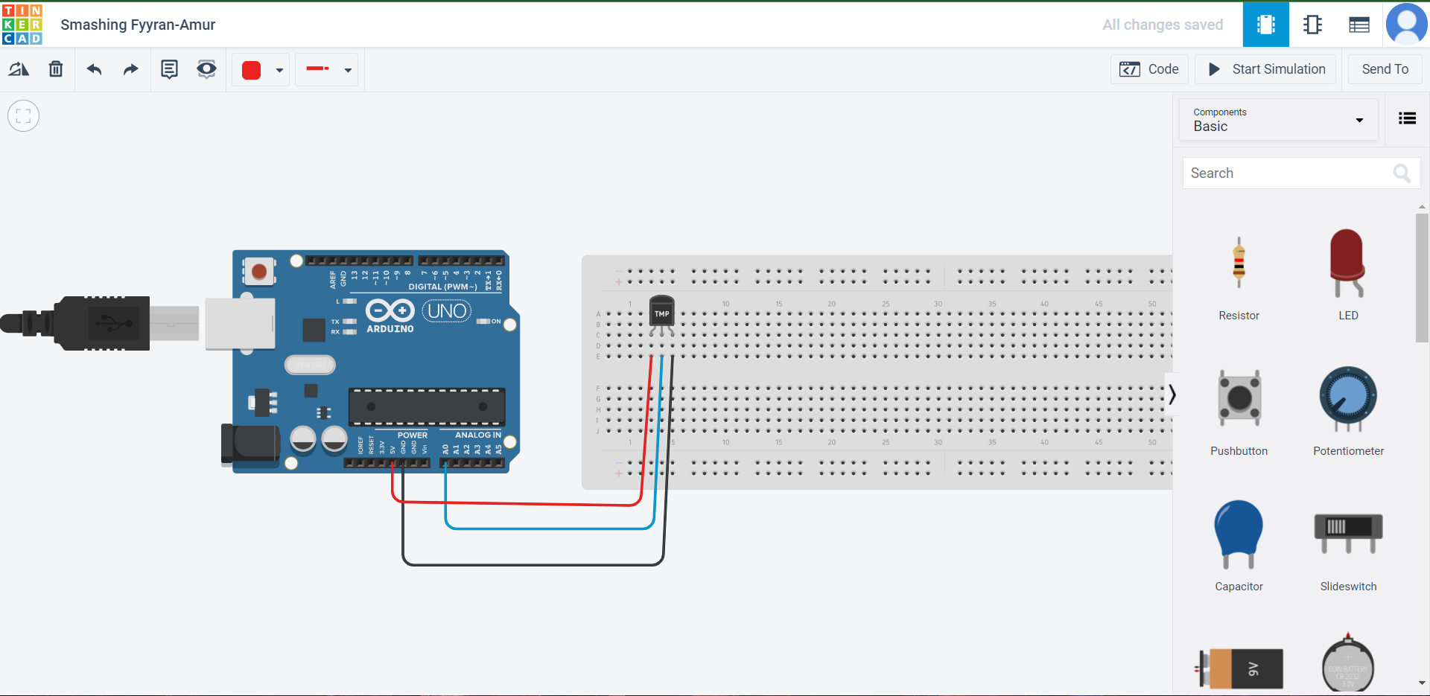

Remember that you can use anywhere between 2.7V and 5.5V as the power supply. For this example, I'm showing it with a 5V supply but note that you can use this with a 3.3v supply just as easily. No matter what supply you use, the analog voltage reading will range from about 0V (ground) to about 1.75V.

If you're using a 5V Arduino, and connecting the sensor directly into an Analog pin, you can use these formulas to turn the 10-bit analog reading into a temperature:

**Voltage at pin in milliVolts = (*reading from ADC*) * (5000/1024)**

This formula converts the number 0-1023 from the ADC into 0-5000mV (= 5V) If you're using a 3.3V Arduino, you'll want to use this:

**Voltage at pin in milliVolts = (*reading from ADC*) * (3300/1024)**

This formula converts the number 0-1023 from the ADC into 0-3300mV (= 3.3V) Then, to convert millivolts into temperature, use this formula:

**Centigrade temperature = [(analog voltage in mV) - 500] / 10**

Simple Thermometer

This example code for Arduino shows a quick way to create a temperature sensor, it simply prints to the serial port what the current temperature is in both Celsius and Fahrenheit

**With text:**

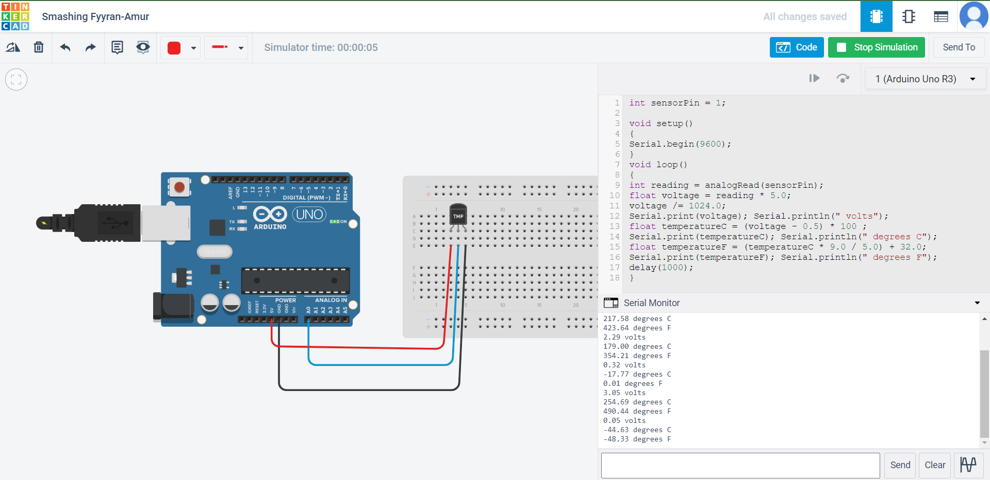

**Code:**

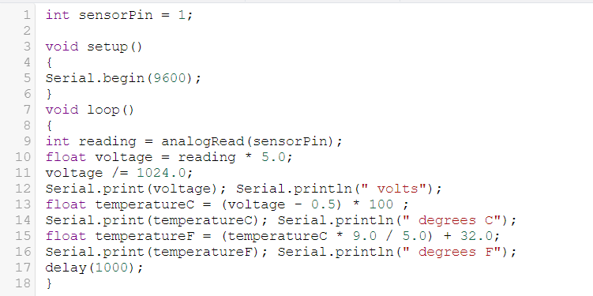

**With blocks:**

1.Connect the circuit as shown below

2.Create a variable name reading and acquire the analog value of A0 into it. observe the output in serial monitor. arrange the code blocks as shown and start simulation. you will see the temperature in serial monitor. vary the input and observe the output.

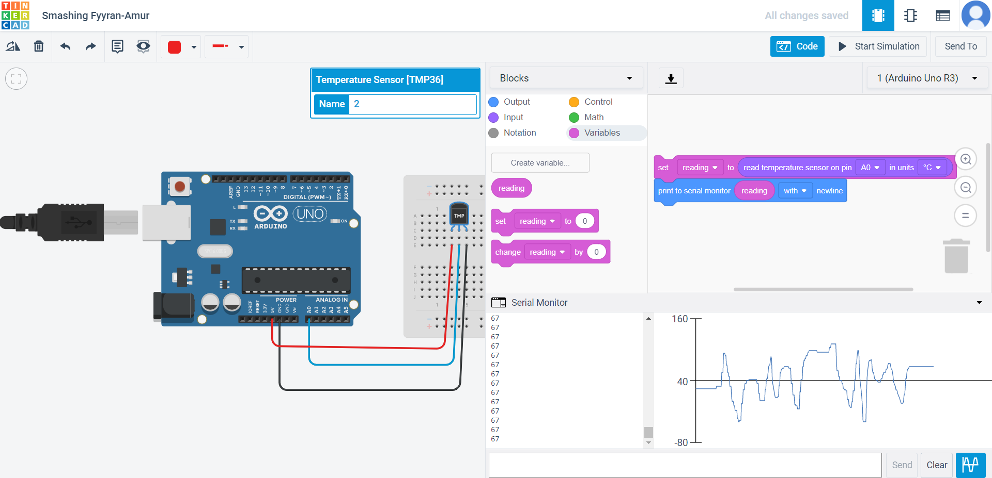

**IR Sensor**

IR sensor is an electronic device, that emits the light in order to sense some object of the surroundings. An [**IR sensor**](https://robu.in/product-category/sensor/ir-and-pir-sensor/) can measure the heat of an object as well as detects the motion. Usually, in the [**infrared spectrum**](https://en.wikipedia.org/wiki/Infrared_spectroscopy), all the objects radiate some form of thermal radiation. These types of radiations are invisible to our eyes, but infrared sensor can detect these radiations.

**Components:**

1. Arduino Uno
2. IR Sensor
3. LED
4. Arduino Cable
5. Jumper wires

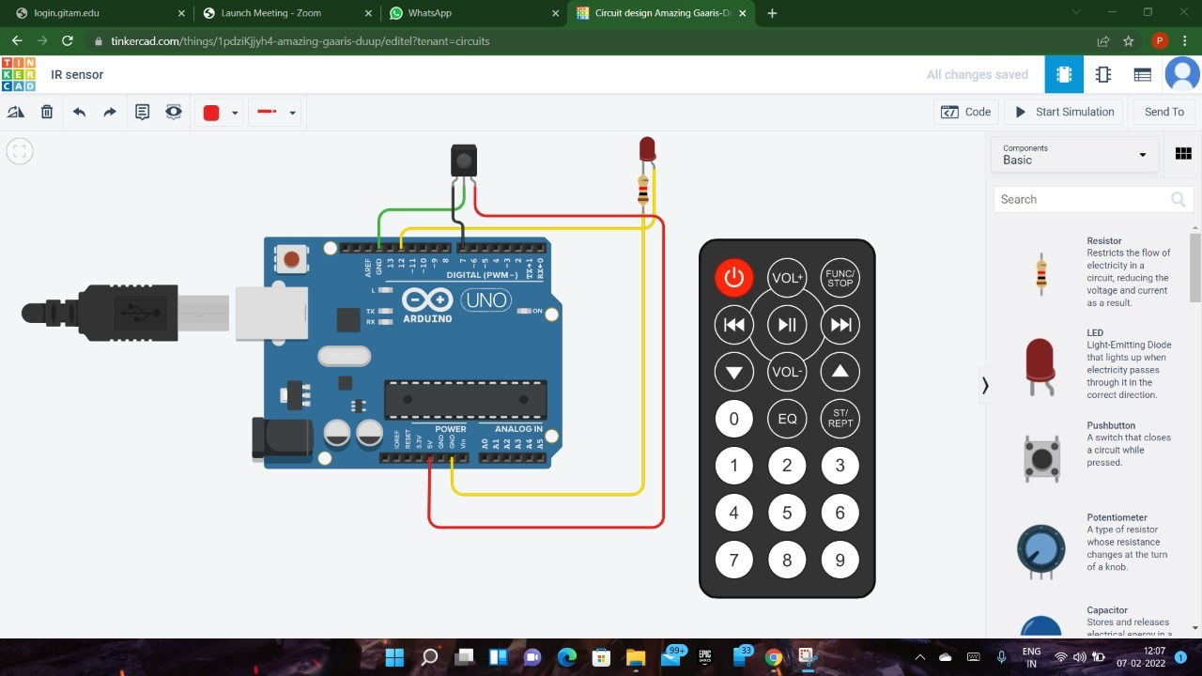

**Code:**

